**UNIT 5 TEST PHASE**

Steps in test Phase, Tips for interviews, Tips for surveys, Kano Model, Desirability Testing, ways to conduct a workshop, Requirements for the space, Material requirements, Agility for Design Thinking.

**Steps in test Phase**

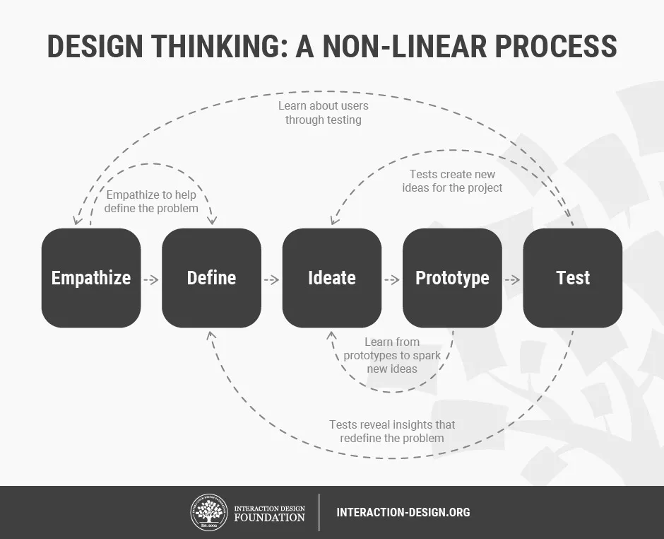

* The five stages of Design Thinking—Empathize, Define, Ideate, Prototype and Test—are not sequential steps in a project. Instead, they are “modes” that you take on during each phase of your project (sometimes in parallel or in iterative loops), as and when they would give you the most learning and value.
* For instance, you can create prototypes early on in the project—ahead of ideation—to help your team empathize with users.
* The test stage of the design thinking process often feeds into the other stages—that’s the beauty of the iterative design process.

**Tips for Interviews**

**3 Key Steps to Prepare for User Interviews**

**1. Set a Goal for Your Interviews**

* You need to form a concise, concrete goal for your user interviews—one that’s related to a specific aspect of your users’ behaviors or motivations is ideal.
* You should ask product stakeholders what they want to learn and base your goal on one of their realistic aspirations.
* Remember, don’t go too broad otherwise your interviews will generate too much irrelevant material. Keep your design needs in mind at all times!

**2. Recruit the Right Participants**

* Once you’ve set a goal, you can move on to recruit participants for the interview.
* You’ll want to ensure you recruit a representative sample of users for your interviews, so you should start with your user personas and try to find interview participants that match them.
* If you have multiple user personas, now is the time to decide whether you want to focus on one particular group of users or several.

**3. Write a Set of Interview Questions**

* Now you’ve got your interviews in the diary, it’s time to create a set of questions to ask your participants. Some tips to help you do so include:
* Before you even start with your questions, script an explanation of the purpose behind the interview—what are you trying to achieve? In this introduction, also explain how the participants’ data and insights will be used.
* Keep leading questions to a minimum—focus on open-ended questions, and leave out the closed-ended questions wherever possible.
* It’s much better to ask “Can you describe to me how you use instant messaging?” than “How often do you use Snapchat?”, for example.
* The former lets you explore what the user actually does whereas the latter presupposes the user uses Snapchat, and that this is the extent of their instant messaging activity. For more information on how and why to use open-ended questions, please see our free template:

**Tips for Survey**

1. **Work out what you want to know:** Work backward and build your survey around the information you need. This helps you decide what types of questions you should ask.
2. **Keep people informed:** Be upfront about the information you need and how long a survey will take. Otherwise, respondents may lose interest, and you’ll lose data.
3. **Know your demographic:** Different groups of people respond to surveys differently. Consider your survey design, how you distribute the survey, and how you structure questions in the context of your target demographic
4. **Always test your survey:** There’s always room for improvement. Check on question drop-off once your survey is live to see if there are opportunities to boost survey response rates.
5. **Use a variety of questions:** Mix up your questions to keep things interesting. A variety of open- and close-ended questions makes a survey more engaging.
6. **Avoid asking leading questions:** These questions infer information about the respondent and create biased responses. For example, “How do you feel about this exciting opportunity?” suggests that the respondent should be excited.
7. **Put your questions in the right order:** Your survey should be conversational. Group similar questions together—for example, start with gathering demographic information before moving on to other questions.

**KANO Model**

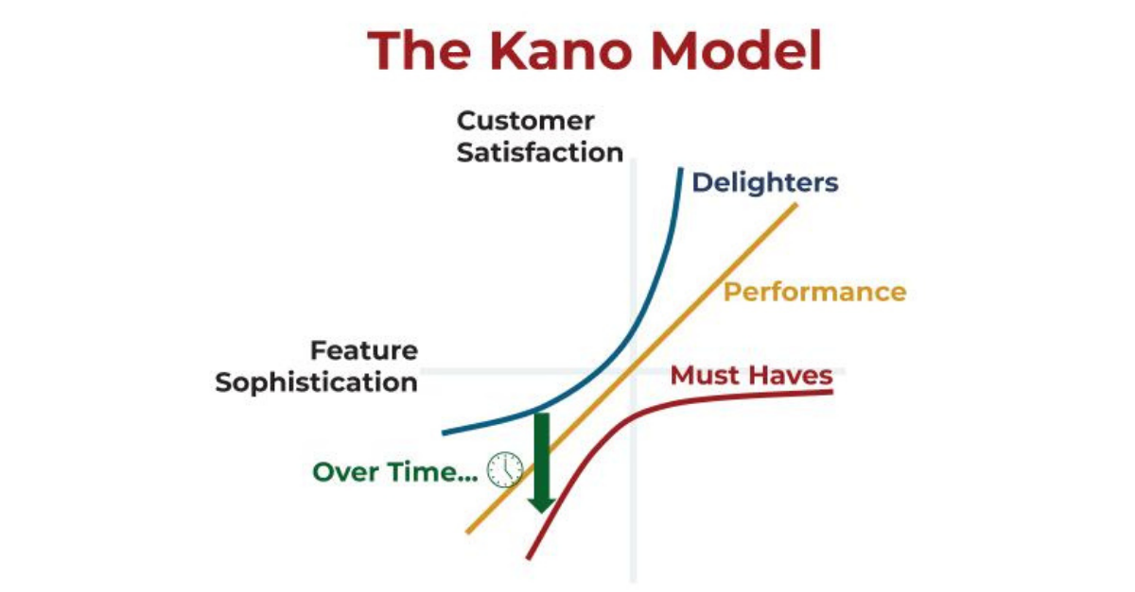

* The Kano Model (pronounced “Kah-no”) is an approach to prioritizing features on a product roadmap based on the degree to which they are likely to satisfy customers.
* Product teams can weigh a high-satisfaction feature against its costs to implement to determine whether or not adding it to the roadmap is a strategically sound decision.
* The Kano Model is one of many prioritization frameworks designed to help product teams prioritize initiatives.
* For example, Kano can help teams determine which features will satisfy and even delight customers.
* Product managers often use the Kano Model to prioritize potential new features by grouping them into categories.
* These feature categories can range from those that could disappoint customers to those likely to satisfy or even delight customers.
* This strict focus on how customers react to each feature distinguishes the Kano Model from other prioritization frameworks.
* The Benefits vs. Cost Model, for example, might use customer satisfaction among its scoring criteria but might also use different criteria, such as increased revenue.
* With the Kano Model, the key consideration for any new feature is how much it will satisfy users.

**How Does the Kano Model Work?**

* Using the Kano Model, product teams pull together a list of potential new features vying for development resources and space on the roadmap. The team will then weigh these features according to two competing criteria:
* Their potential to satisfy customers.
* The investment is needed to implement them.

**What are the Kano Model Feature Categories?**

The Kano Model identifies three types of initiatives product teams will want to develop. We will discuss those below.

It’s also worth pointing out, however, that the model also identifies two types of features you will want to keep off of your roadmap:

“indifferent” features, which customers won’t care about.

“dissatisfaction” features, which will upset customers.

Under the Kano Model, the three categories of initiatives that could earn a slot on your roadmap include:

**Basic (threshold) features**

* These are features your product needs to be competitive. Customers expect these features (such as a car’s turn signal) and take them for granted.
* This means they must be included. And, if they don’t work as expected, they may lead to dissatisfaction.

**Excitement features**

* Excitement features yield a disproportionate increase in customer delight as you invest in them.
* If you don’t have these features, customers might not even miss them; but if you include them and continue to invest in them, you will create dramatic customer delight.
* You can also think of these features as the unique innovations and surprises you include in your product.
* Dr. Noriaki called these “attractive” features and “delighters” because they had that effect on users, and that delight can create an outsized positive response to your product.
* After the internal product team has made its own determinations about which of the potential new features fall into which categories (including the two negative ones—indifference and dissatisfaction), the team will then take the issue directly to users or prospective users with customer surveys, questionnaires, and other feedback methods.

**Performance features**

* These are features that give you a proportionate increase in customer satisfaction as you invest in them.
* One example would be increasing file storage capacity in an online app. Dr. Noriaki described this type of feature as “one-dimensional” because of the direct, linear correlation between how much you invest in it and the amount of customer satisfaction it delivers.
* These also feature customers who know they want and weigh heavily when deciding whether to choose your product or your competitor’s.

**Desirability testing**

* It allows designers to understand what users think about the aesthetics and visual appeal of a product. Just like usability testing, it has a mix of quantitative and qualitative methods that allow us to assess the aesthetics and visual appeal.
* Why is this necessary? You want to understand how users feel about the design. What do they think of the aesthetics and is it visually appealing?

**Some methods of desirability testing include:**

**1. Microsoft Reaction Card Method —** The participant chooses a number of words (from a list of 118 words) that they feel best describes the product. This allows the design team to know what designs cause certain reactions.

**2. Questionnaires or Surveys —** You can ask them questions relating to visual appeal and aesthetics but try not to ask leading questions.

**3. A and B testing —** This method allows you to gauge which version of a design they like better and you can always ask them why did they prefer a certain version over another.

**4.Physiological Indicators —** Similar to eyetracking, these studies track physiological measurements to show how participants react to the designs. These indicators and sensors can identify pupil dilation, respiration, electromyography (EMG — which measures muscle activity).

The most commonly used desirability testing method is the Microsoft Reaction Card Method. Usually there is a mix of positive or negative adjectives and nouns. By having the users choose what words they feel like apply the best to the project, they have more freedom to tell how you they feel about the product.

**Design Thinking Workshop**

How to run a design thinking workshop: a step-by-step guide

Now that you know exactly what a Design Thinking workshop is, let’s dive into how you run one, step by step!

**ways to conduct a workshop, Requirements for the space, Material requirements, Agility for Design Thinking**.

**1. Define the challenge**

What’s the goal of your workshop? Is it to uncover new opportunities, solve a specific user problem, or improve a product or feature? Whatever the challenge is that you’re hoping to solve with the workshop, have it defined well in advance so that everyone is on the same page from the start. It might be helpful to write it out as a question or statement that can be easily referred back to. Eg: “How can we increase traffic to our landing pages?”

**2. Prepare the location**

We’ll talk about how best to run remote workshops later in this article, but for in-person workshops, the location you choose will play a significant role in its success. To keep your attendees relaxed, comfortable, and free to be creative, keep the following checklist in mind while selecting and preparing your workshop’s location:

* Comfortable seating
* Good (preferably natural) lighting
* Space to move freely
* Presentation and storage space
* Snacks and drinks are available
* Available wall space and whiteboards

**3. Write the workshop agenda**

The importance of writing a good workshop agenda should never be underestimated. While putting together your workshop agenda, concentrate on deliverables rather than focusing too heavily on creating a prescription for every moment of the day. Make sure to include lots of activities, be realistic with your time planning, and allow plenty of time for breaks, spontaneity, free-flowing discussion, and creativity.

You’ll probably want to allow approximately one hour for each section of the workshop, with a generous slot dedicated to reflection and debriefing when the activities are over.

**4. Gather your tools**

To ensure maximum creativity, you’ll be going back to basics for your Design Thinking workshop. You’ll want to stock up on white copy paper, colored paper, pencils, marker pens, Post-It notes of different colors, sticky tape, and whiteboards.

* The user’s needs
* The user’s wants
* The user’s feelings
* The user’s language

This is also a good opportunity to assess the current user personas the team are using. How accurate are they? What data was used to inform them? Do they need updating or even overhauling altogether?

**5. Write a problem statement**

Although the general challenge has already been identified, now’s the time to get down to specifics. Having gone through the user’s challenges in the previous exercise, the group is in a better position to go into more detail with the issue itself. This is the time to ask the group to come together to write a detailed problem statement. When the statement’s been written, take a moment to have a brief reflection and discussion on what everybody has learned so far. Did everybody agree with the user’s challenge or were different needs identified?

**6. Ideation and solution session**

Working with the problem the group identified in the previous step, the group spends this next phase working on ideas and possible solutions. As well as traditional brainstorming, try out some of these other idea generation techniques:

* Reverse brainstorming–this is where you focus on the causes of the problem rather than the solution
* Rapid ideation–each person writes down as many ideas as possible within a set timeframe
* Worst idea–ask everyone to come up with their worst idea to solve the problem. As the facilitator, you then have to ask team members to list why these ideas are so bad
* Check out our ultimate 10-minute brainstorming technique, too.

By the end of this session, you and your team need to have settled on one solution.

**7. Map out the user journey**

A user journey map is a visual representation of the process that a user goes through in order to accomplish a specific goal. Now that you’ve got your solution, the team needs to map out each step the user needs to take for it to work.

**8. Build prototypes and test**

It’s time for the team to create low-fidelity prototypes! During this stage, the steps from the user journey will be used to create individual screens or interfaces, including buttons and other interaction points or functionality. It’s worth suggesting to the team to use one piece of paper to represent each screen so that mistakes can be easily rectified and the journey is easy for everyone to follow.

**9. Debrief and next steps**

Finish up your workshop with clear next steps for the team. These might include:

* Creating detailed wireframes
* Building high-fidelity prototypes
* Conducting user testing with real users

This phase can also include a brief retrospective. What did the team learn? What went well? What could have gone better? Did the team have any feedback for you as the facilitator? Make a note of these answers so that your workshops continue to improve steadily over time.